**IOT Based Hydroponic System**

**Dhiraj K Shelke*1, Pranav N Gavali*2, Komal P Naphade*3**

*1Student, Computer Engineering, Sinhgad Academy of Engineering, Pune, Maharashtra, India

*2 Student, Computer Engineering, Sinhgad Academy of Engineering, Pune, Maharashtra, India

*3 Student, Computer Engineering, Sinhgad Academy of Engineering, Pune, Maharashtra, India

**ABSTRACT**

The blast in human population has left scientists scrambling for arrangements on how to take care of the world. Moreover, provincial metropolitan movement i.e. rural-urban immigration has from one perspective left the farms in the rustic regions without farmers and then again has left the metropolitan regions over-populated. Hydroponic is a type of horticulture where yields are developed without soil. This method permits the homesteads to follow the ranchers to the metropolitan region. Also, the truth that no dirt is required, permits Hydroponic framework to be stacked upward (otherwise called vertical cultivating) to save space. The last outskirts in tank-farming is mechanization or automation. It will permit one rancher to work more than one work and develop more than one homestead at the same time. This paper gives an exhaustive review on brilliant Hydroponic framework created to date.

**Keywords:** Hydroponic, Soil, Water, Study.

1. **INTRODUCTION**

The dirt is a significant part of agribusiness [1]: it gives support for the plants, it additionally give supplement to the plants and the soil give a home to a portion of the microbial living being that frames a beneficial interaction relationship with the plants. Be that as it may, this multitude of fixings can be given hydroponics. Hydroponics is the interaction of developing plants without soil [2,1]. Proof of hydroponics was found in the Egyptian divider painting [3]. There are many advantages to hydroponics [1]: 1) it doesn't need soil, 2) it is quicker than conventional cultivating, 3) it requires less space and can be filled in any area, 4) it is unaffected via occasional change, 5) practically no pesticides and herbicides are required 6) Plants get total reach of supplements they need at the amount they need it, 7) Plants are secured against infections and irritations, 8) It can be utilized to seclude crops during tests [4,5,6,7]. Soil-less culture predominantly alludes to the strategies of Hydroponics and Aeroponics. The term Hydroponics was derived from the Greek words hydro - which means water and ponos which implies work. It is a technique for developing plants utilizing mineral supplement arrangements, without soil .Hydroponics is the procedure of developing plants in soil-less condition with their foundations inundated in supplement arrangement. This framework assists with confronting the difficulties of environmental change and likewise helps underway framework the executives for effective usage of normal assets and alleviating lack of healthy sustenance

Figure 1 shows the parts of a hydroponic framework: First there is a requirement for an area or developing region where the framework is going to be introduced since hydroponics require just water any space could be utilized for it. The repository is a holder that stores the supplement arrangement utilized by the framework. Supplements in a decent hydroponic framework should contain the ideal degree of; oxygenation, saltiness, pH, and conductivity of nutrient solution [8]. The hydroponics fertilizers contain six essential nutrients: N, P, S, K, Ca and Mg, which are fed to the plants in form of mutual ratio of anions: NO−3 , H2PO−4 and SO2−4 , and the mutual ratio of cations K+ ,Ca2+ and Mg2+ [9]. Light is vital for photosynthesis, right up front/indoor hydroponic situation light-emitting diodes (LEDs) and different sources of light are utilized to give lighting in lieu of the sun. Different variables that might be considered are; surrounding temperature, nutrient solution temperature, photoperiod, and humidity of air.

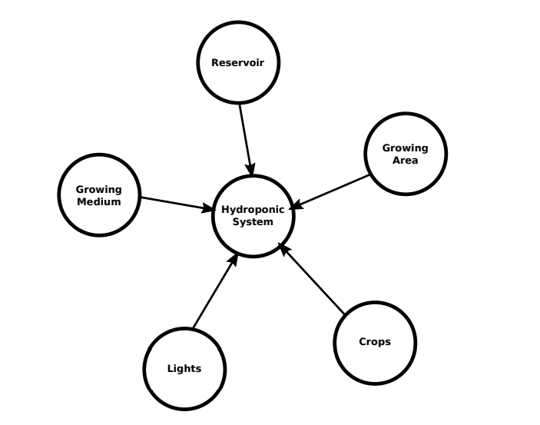

**Figure 1:** Components of Hydroponic System.

1. **METHODOLOGY**

The seed of the selected crop is utilized and set in the yield bed physically. A domestic power supply is utilized to control the framework. The client can pick the crop that will be planted. After the harvest choice is done, the water is pumped from the principle tank to the nutrient blending tank, the water pumping stops once the water level is reached. Here the water is blended in with the supplements in appropriate extents as per chose crop. The pH Sensor is utilized here to gauge the fitting pH level needed for that specific plant. Water pump is utilized to pump water to the plants just as from the plants by this way the water is flowed. The temperature and moistness/humidity of the climate is estimated by temperature sensor.

1. **MODELING AND ANALYSIS**

|  |  |  |
| --- | --- | --- |
|  | | |
|  | Sensor | Use |
| 1. | pH sensor | Measures pH of water. |
| 2. | Air Temperature/ Humidity | Measures temperature and humidity of Air. |
| 3. | Water Temperature sensor | Measures Temperature of water. |
| 4. | RGB Intensity | Measures light intensity. |
| 5. | EC sensor | Measures Electrical Conductivity, which is used to derive Total Dissolved Solid. |

Figure 2: Sensors and Their Uses

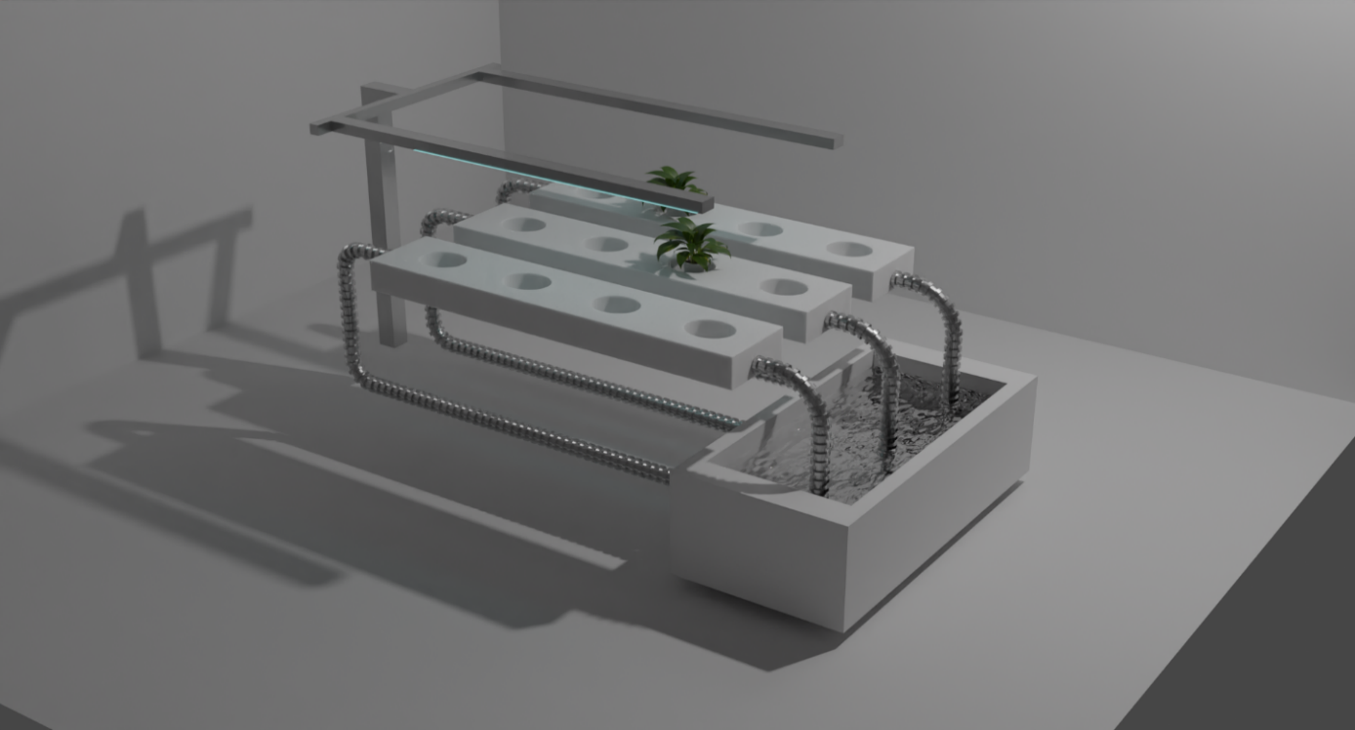

**Figure 3:** 3D view of Hydroponic System Model.

1. **RESULTS AND DISCUSSION**

The hydroponic system assists with expanding in the pace of development of plants contrasted and the customary pace of development of plants in ordinary cultivating [10]. According to the exploratory arrangement, the seeds get developed inside 1 seven day stretch of planting and can support for around fourteen days. The pace of development is almost multiplied in tomato plants. The water content utilized is likewise diminished up-to 60 percent of the measure of water utilized in cultivating, as the system comprises of re-circling water from a decent tank. The quality of the yield and the market esteem is likewise higher than soil developed plants as there is practically none weeding. The plant stature is too higher than customary soil cultivating. Inside a recognizable time range, the plants arrive at a helpful stature, which is sign towards a solid plant development. This recognizable change isn't noticed rapidly in conventional cultivating when contrasted with hydroponics system.

The line systems last longer whenever kept up with and the water temperature is additionally at the ideal level. The need of presenting water solvent supplements has about a stretch of time of around 1 seven day stretch of span. The Android application assists with observing the boundaries from anyplace on the planet. There are right now no versatile applications for hydroponics accessible in the application store or then again Google play store. The disconnected information base aides anybody anyplace to investigate what sorts of plants seeds they can purchase.

Simple, one-tap way to deal with most recent news and Google maps, showing hydroponics stores by utilizing GPS, assists with being quick and precise.

1. **CONCLUSION**

In this review, the yields are developed without the utilization of soil, rather the supplements from the dirt are straightforwardly given to the harvests by water supply. The sufficient supplements that are needed by the plants are estimated and added to the water repository with the goal that the yields get an adequate number of supplements from the water as equivalent as from the dirt. By the mediation of IoT this entire hydroponic framework can be mechanized. The business is relied upon to grow exponentially in future, as states of soil for agriculture is becoming troublesome. Extraordinarily, in a nation like India, where metropolitan substantial combination is developing every day, there is no choice except for embracing soil-less culture to assist with working on the yield and nature of the produce so that we can guarantee food security of our country. Notwithstanding, Government intercession and Research Institute interest can drive the utilization of this innovation. Hence, this hydroponic framework can be taken on in any natural conditions and it is a mechanized arrangement that utilizes IoT as its Weapon.

**ACKNOWLEDGEMENTS**

We take this opportunity to express our sincere thanks and gratitude to all those who helped us to complete the project successfully. At the outset, we are greatly indebted to our guide, Prof. A. Adapanawar, Head, Department of Computer Engineering, for his advice, creative guidance, valuable suggestions, support and encouragement throughout the project. Our sincere thanks to Dr. K. P. Patil, Principal, Sinhgad Academy of Engineering, Mysore, for his encouragement and constant support. We would like to thank our project coordinators Prof. S. N. Shelke, Department of Computer Engineering for their support and guidance. We thank all our Department Teaching and Non-Teaching staff who helped us to complete this work.

1. **REFERENCES**

[1] T. Baras, DIY Hydroponic Gardens: How to Design and Build an Inexpensive System for Growing Plants in Water. Cool Springs Press, 2018. [Online]. Available: https://books.google.com.sa/books?id=rwlMDwAAQBAJ

[2] D. Singh, J. Davidson, and M. Books, Introduction to Hydroponics - Growing Your Plants Without Any Soil, ser. Gardening Series. Mendon Cottage Books, 2016. [Online]. Available: <https://books.google.com.sa/books?id=RAMtDQAAQBAJ>

[3] M. Raviv and J. Lieth, Soilless Culture: Theory and Practice. Elsevier Science, 2007. [Online]. Available: https://books.google.com.sa/books?id= NvDHJxRwsgYC

[4] W. Ke and Z. Xiong, “Difference of growth, copper accumulation and mineral element uptake in two elsholtzia haichowensis populations under copper and mineral nutrition stress,” in 2008 2nd International Conference on Bioinformatics and Biomedical Engineering. IEEE, 2008, pp. 4704–4708.

[5] H. Wang, Y. Wang, and Y. Yang, “Effects of exogenous phenolic acids on roots of poplar hydroponic cuttings,” in 2011 International Conference on Remote Sensing, Environment and Transportation Engineering. IEEE, 2011, pp. 8245–8249.

[6] N. Suzui, N. Kawachi, M. Yamaguchi, N. S. Ishioka, and S. Fujimaki, “A monitoring system of radioactive tracers in hydroponic solution for research on plant physiology,” in 2009 1st International Conference on Advancements in Nuclear Instrumentation, Measurement Methods and their Applications. IEEE, 2009, pp. 1–3.

[7] M. Liu, X. Xi, S. Wang, Y. Xu, and W. Song, “Research on differences of component and quantity of organic acids in the root exudates among the three green manures,” in World Automation Congress 2012. IEEE, 2012, pp. 1–4.

[8] G. Gupta, Text Book of Plant Diseases. Discovery Publishing House, 2004. [Online]. Available: https://books.google.com.sa/books?id=OuoicDXQ-xYCT. Kaewwiset and T. Yooyativong, “Estimation of electrical conductivity and ph in hydroponic nutrient mixing system using linear regression algorithm,” in 2017 International Conference on Digital Arts, Media and Technology (ICDAMT). IEEE, 2017, pp. 1–5

1. Ehsan Tavakkoli, Pichu Rengasamy and Glenn K. McDonald, “The response of bar-ley to salinity stress differs between hydroponic and soil systems”, Functional Plant Biology, Vol. 37, pp. 621 - 633, 2010.